

Project name: DESIGN AND DEVELOPMENT OF ENERGY MONITORING AND VISUALIZATION PLATFORM FOR MUTLI- FUNCTION METERS

ABSTRACT

As the need for efficient energy usage in campuses and commercial facilities increases, real-time monitoring of electrical parameters has become essential. Traditional manual meter reading is slow, error-prone and cannot provide real-time data or historical analysis. With multiple power sources such as MSEDCL grid supply and Diesel Generators, an automated monitoring system is required for proper energy management.
Existing energy monitoring systems often lack proper cloud integration, multi-source data separation, remote access and advanced visualization, which affects accurate energy analysis and decision-making.
This project presents an IoT-based energy monitoring and visualization platform using two smart meters - Secure Elite 440 (Grid) and Secure Elite 300 (DG) - connected to a Teltonika TRB245 gateway via RS-485 Modbus RTU. The gateway sends MQTT data to AWS IoT Core, where a Node.js backend processes the data, separates meter sources using server_id and stores it in DynamoDB. A web dashboard built with HTML, CSS, JavaScript and Chart.js displays real-time readings, graphs and historical data.
The system provides accurate meter segregation, real-time monitoring and reliable data storage, making it suitable for scalable deployment in colleges, industries and commercial buildings for better energy management.

1-INTRODUCTION

1.1 Problem Statement
Real-time monitoring and efficient management of power consumption have become highly important in the present era of rising energy demands and increasing costs of electricity. The college campus makes use of two types of energy sources viz the utility grid supply (MSEDCL) and Diesel Generators (DG) for backup during grid failure to fulfill electrical needs. However, the manual tracking in use today is prone to human errors; real-time visibility during source switching is lacking and provides no historical data for the analysis or optimization of energy.
To overcome these shortcomings, the proposed work "Design and Development of Energy Monitoring and Visualization Platform for Multifunction energy meters" attempts to develop a centralized intelligent energy data monitoring system. The proposed platform will continuously fetch, process and visualize real-time energy data from Multifunction Meters and provide an overall view of power usage at various energy sources. It will facilitate real-time source-wise comparison between MSEDCL and DG supply apart from maintaining historical consumption records useful for energy audits, performance evaluation and optimization of power usage.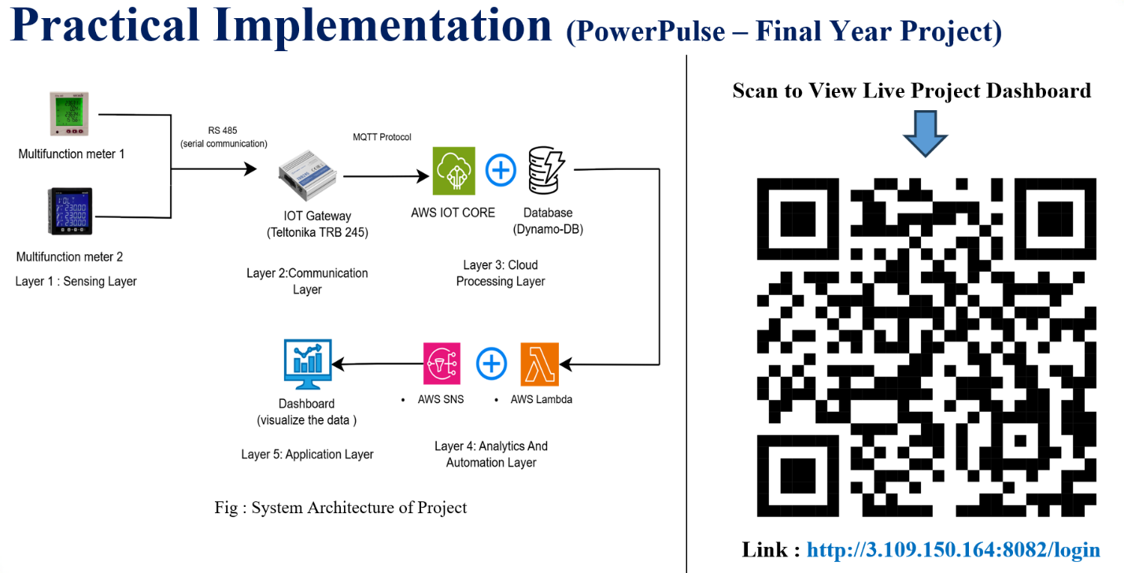

1.2 Objectives of the Project
The main objectives of this project are as follows:
- To design and develop a centralized platform for real-time monitoring of energy consumption from multifunction energy meters.
- To enable the acquisition of data through the Modbus RTU protocol for correct and continuous measurement of energy parameters.
- To ensure secure and reliable data transmission using industrial communication protocols and cloud services.
- To implement a real-time energy data and historical trends' visualization Web-based dashboard supported by dynamic charts and tables.
- To provide source-wise comparison between MSEDCL (grid supply) and DG (Diesel Generator) for performance evaluation.
- To keep historical consumption records for subsequent energy audit, optimization+ and decision-making purposes.
- To reduce manual intervention and hence minimize human error in energy data recording and reporting.
- To implement an automated report generation system that provides daily, weekly and monthly energy consumption summaries.
- To enable source-wise analysis (MSEDCL and DG) through structured reports for effective energy auditing and decision-making. To support scalability, allowing additional meters and gateways without architectural changes.
- To align the system with energy efficiency, power quality monitoring and Sustainable Development Goal (SDG-7)

1.3 Methodology Overview
The project follows a systematic approach beginning with problem analysis and requirement identification. This is followed by system design, implementation and testing. Appropriate hardware/software tools are used to develop the system and results are analysed to validate the effectiveness of the proposed solution.

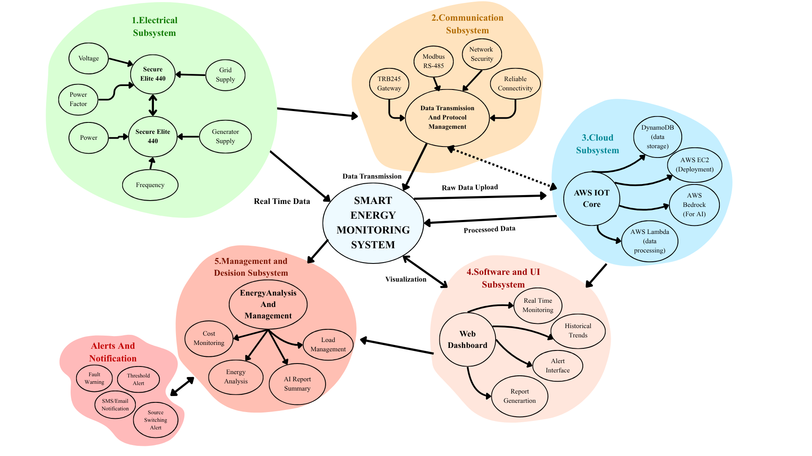
1.4 SOCME (Systems-Oriented Concept Map Extension)

2-METHODOLOGY
The Development of the Energy Monitoring and Visualization Platform followed a systematic approach that involved hardware integration, communication setup, cloud configuration, backend development and frontend visualization. This approach ensures successful acquisition of data and transmission through security measures as well as efficient storage and effective visualizations in real-time.

2.1 System Architecture Overview
The system architecture consists of four major layers:
- Data Acquisition Layer – Multifunctional energy meters (Secure Elite 440 and Secure Elite 300) are responsible for measuring the real-time values of electricity characteristics like voltage, current, power factor, frequency, and consumed energy.
- Communication Layer – Both meters exchange data through RS-485 Modbus RTU protocol to Teltonika TRB245 IoT Gateway.
- Cloud Processing Layer – Gateway sends data to AWS IoT Core using MQTT protocol [10] for further processing.
- Application Layer – Node.js + Express.js server processes collected data and saves it in DynamoDB database; web dashboard displays current and historical energy statistics.
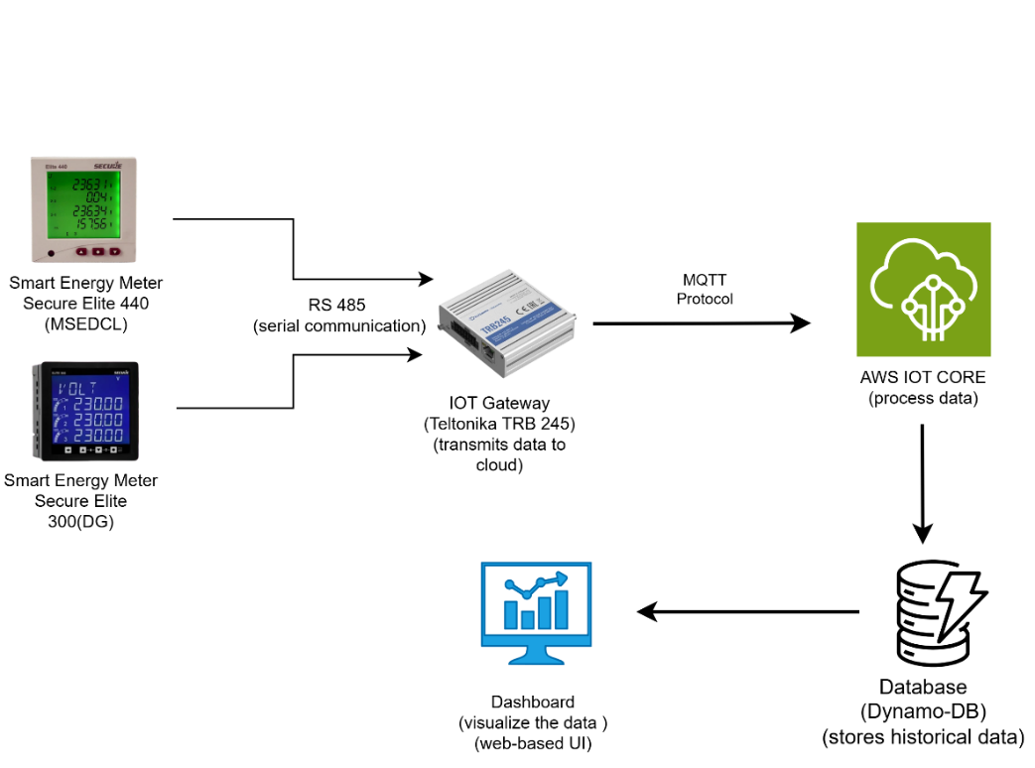

Fig. 2 Basic System Architecture

2.2 Step-by-Step Methodology
- Hardware Setup
- Installed Secure Elite 440 and Elite 300 Multifunction Meters at respective monitoring points for MSEDCL (grid) and DG (diesel generator) supplies.
  - Configured the meters for Modbus RTU communication using unique slave IDs and baud rate settings (9600 bps).
  - Connected both meters to the Teltonika TRB245 gateway using a RS-485 cable to ensure stable serial communication.
- Gateway Configuration
  - Accessed the TRB245 web interface for setup.
  - Configured the RS-485 interface and defined Modbus registers to read parameters from the energy meters.
  - Integrated the MQTT client on the gateway to publish real-time data to the AWS IoT Core endpoint using secure authentication credentials.
- Cloud and Backend Development
  - Created an AWS IOT Core instance to receive and manage device-to-cloud messages.
  - Developed a Node.js + Express.js backend to subscribe to the IoT Hub and handle data parsing, validation and conversion into structured formats.
  - Implemented data storage using DynamoDB, designed for efficient retrieval of both real-time and historical datasets.
- Dashboard Design and Visualization
  - Built a responsive web dashboard using modern web technologies (HTML, CSS, JavaScript).
  - Integrated backend APIs to fetch processed data from DynamoDB and display dynamic charts and tables.
  - Enabled source-wise comparison (MSEDCL vs DG) and time-based filtering for performance and energy audit analysis.
- Testing and Troubleshooting
  - Verified Modbus data accuracy by comparing meter readings with values received at the gateway.
  - Resolved MQTT message formatting and WebSocket parsing issues to ensure real-time dashboard updates.
  - Conducted latency and reliability testing for data flow from meter to cloud to dashboard

2.3 Workflow Summary
- Measurement: Energy parameters recorded by Secure Elite meters.
- Transmission: Data sent via RS-485 (Modbus RTU) to TRB245 gateway.
- Publishing: Gateway sends data to AWS IoT Core using MQTT.
- Processing: Node.js + Express.js backend processes and stores data in DynamoDB.
- Visualization: Web dashboard displays real-time and historical analytics for monitoring and optimization.

2.4 Outcome of Phase 1
At the conclusion of Phase 1, the team was able to:
- Create a reliable communication link between the multifunction energy meter and IoT Gateway using RS-485 Modbus RTU communication protocol.
- Successfully extract and transmit the real-time energy data to Azure IoT Hub cloud platform via MQTT protocol.
- Create an initial backend/dashboard for the visualization of electrical parameters and historical monitoring.
- Successfully conduct cloud-based monitoring and visualization, thus laying a foundation for subsequent developments.
- Publish a research/review paper based on the findings and implementation of energy monitoring system.
Phase 1 created a solid groundwork for the upcoming phases that will deal with advanced analytics and AI-powered insights, among others.This methodology lays a strong foundation for the next phase, which will focus on advanced analytics, three-phase integration and optimization algorithms for intelligent energy management.

2.5 Specifications of the System
A. Hardware Specifications
- Multifunction energy meters
  - Model 1: Secure Elite 440
  - Model 2: Secure Elite 300
  - Communication Protocol: Modbus RTU
  - Measured Parameters: Voltage, Current, Power Factor, Active Power, Reactive Power, Frequency
  - Supply Voltage: 230 V / 415 V AC
  - Accuracy Class: 0.5S / 1.0
  - Purpose: Real-time monitoring of energy consumption from MSEDCL and DG supplies
- Teltonika TRB245 Gateway
  - Communication Interface: RS-485 (for Modbus RTU data acquisition)
  - Connectivity: 4G LTE with fallback to 3G/2G
  - Network Protocol: MQTT for IoT communication
  - SIM Support: Mini SIM (2FF)
  - Power Supply: 9–30 V DC
  - Purpose: Transmits energy meter data to the AWS IoT Core for cloud processing
- RS-485 Cable
  - Type: Twisted pair shielded cable
  - Length: As per installation requirement
  - Purpose: Reliable and noise-immune communication link between energy meters and gateway.
- Power Supply Unit
  - Input: 230 V AC
  - Output: 12 V DC (for powering gateway and other low-voltage devices)
B. Software Specifications
Backend Platform
  - Cloud Service: AWS IoT Core
  - Framework: Node.js with Express.js for data handling and API integration
  - Function: Acts as the central data processing unit that collects incoming MQTT data, processes it and stores it in the database
  - Data Flow: Energy Meter → TRB245 Gateway → AWS IoT Core → Node.js Backend → DynamoDB Database
  - DatabaseType: DynamoDB (NoSQL Database)
  - Function: Stores real-time and historical energy data for analysis and visualization
Frontend (Web Dashboard)
  - Technology Stack: HTML, CSS, JavaScript (Chart.js)
  - Features: 1. Real-time data visualization through charts and tables.
2. Source-wise comparison between MSEDCL and DG Historical trend analysis and data filtering.
3. User-friendly interface for performance monitoring and energy
auditing
.
Communication Protocols
  - Modbus RTU: For data acquisition from energy meters.
  - RS-485: For serial communication between meters and gateway.
  - MQTT: For transmitting processed data from gateway to the AWS IoT Core.
C. System Performance Specifications
  - Data Refresh Rate: Real-time (configurable interval)
  - Data Accuracy: ±1% (based on meter precision)
  - Communication Range: Up to 1200 meters (as per RS-485 standard)
  - Dashboard Accessibility: Web browser-based (accessible from any device with internet connection)
  - Cloud Connectivity: Secure MQTT communication via AWS IoT Core

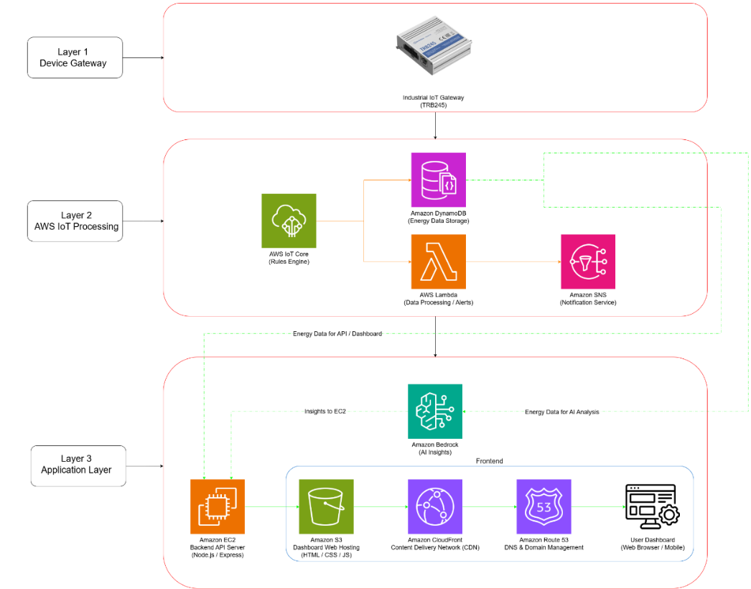
3.Cloud Architecture
Fig. : Cloud Architecture of System

3.1 Itroduction
The proposed system is a cloud-integrated IoT-based energy monitoring and analytics platform designed for real-time acquisition, processing, storage, visualization and intelligent analysis of electrical parameters. The architecture combines Industrial IoT devices with AWS cloud services to create a scalable, secure and intelligent monitoring ecosystem.
The system continuously collects energy meter data through an Industrial IoT gateway and transmits it to AWS cloud services using MQTT protocol. The collected data is processed in real time, stored securely, analyzed using Artificial Intelligence and visualized on a web-based dashboard for users.
The architecture is divided into three major layers:
- Device Gateway Layer
- AWS IoT Processing Layer
- Application Layer
This layered architecture improves scalability, modularity, maintainability and system reliability.

3.2 Summary of software design
The software design of the proposed Energy Monitoring and Visualization Platform provides a reliable and scalable framework for real-time energy data acquisition, processing, storage and visualization. The system integrates frontend technologies, backend services, cloud computing and database management to enable efficient monitoring of Grid and DG energy sources.
The frontend dashboard is developed using HTML, CSS, JavaScript and Chart.js to display real-time and historical electrical parameters through dynamic charts and tables. The backend is implemented using Node.js and Express.js, which process MQTT data received from AWS IoT Core, segregate meter data using server_id and store it in DynamoDB for further analysis.
AWS cloud services such as AWS IoT Core, DynamoDB, Lambda, EC2, SNS and Bedrock are integrated to support secure communication, data storage, alert generation, automated reporting and AI-based analytics. WebSockets are used for live dashboard updates, while REST APIs provide historical data access and filtering.
Overall, the software architecture ensures secure communication, efficient data handling, real-time visualization and intelligent analysis, making the system suitable for scalable energy monitoring applications.

4.CONCLUSION
- The system successfully collects real-time energy data from two Multifunction Meters (Grid and DG) using RS-485 Modbus communication.
- Reliable data transmission to AWS IoT Core through the Teltonika TRB245 gateway was achieved using MQTT protocol.
- The backend correctly parses and separates the two meter data using server_id and stores them in DynamoDB.
- A web dashboard was developed which displays real-time and historical data using charts and tables.
- Grid and Generator parameters such as voltage, current, power factor, frequency, active power and apparent power were visualized clearly.
- The system was tested and found to be stable, accurate and capable of updating the dashboard with minimal delay.
- The platform provides useful insights that help in understanding power usage, load behaviour and variations in electrical parameters.
- Furthermore, the system is enhanced with the use of an AI-based chatbot through Amazon Bedrock, which enables users to use natural language to query the energy data.
Incorporating the use of advanced models such as Claude Haiku and ChatGPT enhances the system's accessibility through the provision of instant insights from the data being monitored.
- The system includes an automated report generation feature that produces structured energy consumption summaries from Amazon DynamoDB data.
These reports enable efficient analysis of grid and generator usage, supporting energy auditing and informed decision-making.
- The experimental evaluation of the proposed system proved the efficacy of the system with near real-time communication delay of about 0.8 seconds on average. Historical data fetching, segregation of sources and automated report generation functionalities worked successfully during the experiments.
- The system also aids in achieving the United Nations Sustainable Development Goal no. 7 of effective energy monitoring and optimum energy consumption. The modular cloud-based structure of the proposed system allows scalability for implementation in bigger organizational campuses, commercial buildings and industrial energy monitoring applications.
- In summary, the project achieved its goal of designing and developing a functional IoT-based energy monitoring and visualization platform. MQTT-based communication integrated with AWS IoT Core enables secure and efficient real-time data transmission between distributed IoT devices and cloud infrastructure [4] .All core components including Multifunction Meters, the IoT gateway, AWS IoT Core, backend services and the dashboard-worked together smoothly to provide continuous monitoring. The accuracy of the readings was verified through quantitative results during the test procedure and proper data segregation and real-time update of the dashboard was noted. Cloud-based visualization of data makes the process easier to interpret and analyze due to the use of interactive dashboards and real-time analytics [6].
- In summary, the developed system offers an easy and reliable way of assessing the performance of both Grid and DG systems, thus providing a good platform for future developments like reporting and alerts among others..

